**Background and Significance**

In this analysis, we explore the association between county-level PM2.5 concentrations in California and asthma emergency department (ED) visit rates among California residents. We hypothesize exposure to higher concentrations of fine particulate matter (PM 2.5) will be associated with higher county-level asthma ED visit prevalence, reflecting exacerbation of existing asthma and new-onset of asthma symptoms.

Nationally, the standard for PM 2.5 concentration is 12 micrograms per cubic meter (ug/m3) and concentrations at 12 ug/m3 or above are risk factors for asthma exacerbation and are generally harmful to health [7]. California has some of the strictest air quality standards, but the state suffers from poor air quality given its large population, mountainous terrain, and generally warm climate that can trap air and collect pollutants [18]. Furthermore, as climate change progresses, wildfires in California and other western states significantly contribute to poor air quality concerns and have consequences for those sensitive to air quality or have asthma. There are several mechanisms that explain how asthma is impacted by environmental pollutants. While there are genetic components to asthma and asthma susceptibility, air pollutants are thought to influence asthma onset via four main ways: oxidative stress and damage, airway remodeling, inflammatory pathways and immune responses, and respiratory sensitization [11]. PM2.5 specifically has been shown to cause airway inflammation as well as oxidative stress. Several epidemiological studies have attempted to highlight the causal association between PM 2.5 in asthma. A recent study in Southern California found that a reduction of 8.1 ug/m3 was significantly associated with a decrease of 1.53 pediatric asthma cases per 100 person-years [9]. Another study of individuals of all ages living in California’s San Joaquin valley found an increased odds of asthma-related ED visits (OR: 1.82, 95% CI 1.11 2.98) [14] and a recent US based study found that even a small increase in PM 2.5 (12% or 1 ug/cm3) was associated with increases of weekly inhaler use by 0.82% [16]. Many of these associations are adjusted for age, season, race, and income.

Based on the clear associations previously identified between PM 2.5 and asthma, and the biological plausibility of the association, this problem appears to negatively affect health. Costs related to PM 2.5 appear to be far-reaching: Williams et al., 2019 estimated that a nationwide 1 ug/m3 reduction in PM 2.5 could save 350 million dollars annually, largely due to healthcare costs [16]. Moreover, research shows that childhood asthma accounts for 50 billion dollars in annual healthcare expenditures in the U.S. and is a major cause of emergency room visits, hospital admissions, absences from school for children, and loss of workdays for parents [7]. It is predicted these effects will grow in cost [10]. Global asthma prevalence has already increased substantially in recent decades, though it is hard to attribute this increase specifically to anthropogenic changes [5].

**The Dataset**

This analysis involved two datasets, one containing California asthma ED visit data and another with fine particulate matter data in California. The particular matter data came from KidsData.org though the original data source is the California Environmental Protection Agency Air Resource Board. This contained data for the exposure variable, PM 2.5, which was a measure of the area range concentration of fine particulate matter, or particulates < 2.5 microns, in the air (KidsData). Measurements were taken every three days and on days with high air pollution concentrations. The emergency visit data came from the California Open Data Portal [6]. The data was a source dataset from Let’s Get Healthy California (LGHC), which aims to collect data on key health indicators. The dataset contained counts and rates (per 10,000 residents) of ED visits at licensed CA hospitals for asthma organized by county, age group, and additional strata. Asthma ED rate in this analysis is the outcome variable. Visit rates were collected using ICD-9 codes in primary discharge diagnosis codes by county and age group.

Two potential confounders were identified in the dataset: age and sex. In the dataset, the age variable was presented as age groups (all ages, 0-17, 18+) of residents in California. Age was considered as a potential confounder since it can be associated with both the exposure and outcome variables. Asthma can develop for anyone at any age in life but, most asthma patients experience their first symptoms at a young age. Asthma is a common chronic disease affecting children. It is estimated that approximately 50% of children with asthma can outgrow their asthma disorder as they reach adolescence, although asthma may return when they pass adulthood [1]. On the other hand, asthma can create a much higher risk for older adults because they are more likely to develop respiratory failure and thus seek emergency care [2]. Also, older patients with mild asthma symptoms can have the same level of breathing difficulty as younger patients with severe asthma symptoms [2]. Therefore, a person’s asthma symptoms and severity may differ by age groups, influencing their rates of asthma-associated ED visits. Furthermore, people in different age groups may experience different levels of exposure to fine particulate matter. This can be influenced by age-related variations in factors such as health conditions, lifestyle, and social behaviors, which may limit or increase their exposure to fine particulate matter.

Sex, either male or female in this dataset, can be another confounder of ED asthma rates and fine particulate matter. Research shows that asthma appears to be more prevalent in boys in the first decade of life but becomes more prevalent in young women after puberty [17]. Similarly, several studies support that the risk of asthma is higher in adult women than in adult men and that females have an increased risk of asthma exacerbations [8,15]. Therefore, a female predominance in asthma disorders may be observed in adolescent and adult populations, which may lead to more asthma ED visits by females than by males. In addition, females and males may experience different levels of exposure to fine particulate matter due to gender-based differences in factors such as lifestyle choices, health beliefs, and social and health behaviors, which may increase or decrease their exposure to fine particle air pollution.

**Unstratified Analysis**

We hypothesize that there exists a positive relationship between high concentrations of PM 2.5 and asthma ED visits at a California county-level. We expect a positive relationship given the aforementioned biological associations between the variables. After plotting our exposure variable against our outcome variable, we found some indication of a positive relationship from the points alone. However, after fitting a linear model onto the plot, a line indicating a positive correlation was shown (Figure 1).

Both PM and Rate of Asthma are continuous variables, neither of which demonstrated enough normalcy after plotting their frequencies on a histogram (Figure 2, Figure 3). The histogram indicates a positive right skew, and a nominal number of outliers in both variables. This skew most likely occurred as a result of the lower boundary within the data set. As both the outcome and exposure variables are continuous and display a right skew, a Spearman correlation test was implemented to evaluate their relationship. The null hypothesis is that there is no relationship between PM 2.5 and Rates of Asthma, and the alternative hypothesis is that a relationship exists between these variables. The p-value (3.888e-05) indicates that we can reject the null hypothesis, and the correlation coefficient (0.26) indicates that a weak positive correlation exists between these variables.

**Stratified Analysis (Confounder 1, Gender)**

In the scatterplots constructed with stratification by gender (male, female) some indication of a positive correlation was displayed in both plots, this was further supported after a linear model was fit (Figure 4). Without performing a regression analysis, we can only judge any potential relationship between the variables by the perceived steepness of the lines fitted onto each plot, and it would appear there is a slightly more defined steepness in the plot categorized by males compared to the plot categorized by females.

**Stratified Analysis (Confounder 2, Age)**

In the scatterplots constructed with stratification by age (18 and over, under 18), indication of a positive correlation was displayed in both plots and this was further supported after a linear model was fit (Figure 5). Without performing a regression analysis, we can only judge any potential relationship between the variables by the perceived steepness of the lines fitted onto each plot. For those 18 and over, a relatively flat line is displayed, indicating a weak positive correlation. When looking at the individuals 18 and under category, a much steeper slope is displayed, indicating that there may be a strong relationship.

**Limitations**

First, it is important to state that these data were collected on the aggregate level and are thus subject to the ecological fallacy. We cannot infer about the relationship between *individual* PM 2.5 exposure and ED visit frequency. Aside from aggregate data, these variables in our analyses have been widely used in other studies to explore the association between fine particle air pollution and asthma. Several studies show a relationship between fine particle air pollution and asthma ED visits by including similar variables in their analyses. Thus, we can infer the association revealed by our analyses meets Hill’s criteria of consistency. Our analyses indicate a dose-response relationship: increased exposure to PM 2.5 resulted in increased rates of asthma ED visits, which is in favor of the biological gradient criteria. For plausibility and coherence, our analyses aimed to prove a cause-and-effect relationship to be seen as consistent with the current body of knowledge on the etiology and mechanism of asthma - researchers have long linked asthma with exposure to air pollution. However, the datasets only provide cross-sectional data and our analyses are retrospective, not allowing us to establish temporality that ensures a temporal progression between exposure and outcome. Also, we are unable to draw evidence from experimental manipulation using the datasets and analyses, as they only contain secondary cross-sectional data. The datasets and analyses do not contain information to allow us to further determine specificity, i.e., exposure to PM 2.5 causes only higher rates of asthma ED visits. The analyses yielded no strong correlation between exposure and outcome, weakening the likelihood of a causal association.

Confounding and measurement errors can be sources of potential bias in the analyses. Although we stratified data by age group and sex, we did not consider other potential confounders and effect modifiers in the analyses. Evidence shows that childhood asthma severity is associated with “duration of asthma symptoms, medication use, low socioeconomic status, and racial/ethnic minorities,” whereas adult asthma severity is associated with “obesity, smoking, and low socioeconomic status” [15]. Thus, factors like socioeconomic status and race/ethnicity are both potential confounders of this analyses. We did not adjust for geographical heterogeneity and account for changes over time in the analysis to eliminate confounding by factors varying across counties and long-term trends. One way to account for long-term time trends can be to include calendar year as a categorical variable. We also did not consider potential effect modification by fine particulate composition. A study has found “early life exposure to PM2.5 and its chemical components is associated with an increased risk of asthma development in children,” indicating the need to consider the heterogeneous nature of PM 2.5 for health risk assessments [13]. Secondly, measurement errors in asthma ED visit rates and PM 2.5 are both important considerations. There is evidence asthma is widely misdiagnosed, so data may not capture true rates of asthma ED visits. PM 2.5 monitors are also in mostly urban areas and may not be reflective of PM variability within counties.

**Conclusions**

We conclude that there is a moderately positive correlation between exposure to concentrations of PM 2.5 and asthma ED visit rates in California residents at the county level. A moderately positive relationship between exposure and outcome variables were observed in results from both the unstratified and stratified analyses.

**Acknowledgements**

Work was divided evenly. Ahmed: data management, and relationship analysis through R, Madeline: identified the datasets, background research, plots in R. Yidan: literature review, write-up sections - the dataset, limitations, conclusions.

**REFERENCES**

1.Asthma and Allergy Foundation of America New England Chapter (AAFA New England). (2021a). *Asthma in Infants and Young Children*. Retrieved from <https://asthmaandallergies.org/asthma-allergies/asthma-in-infants-and-young-children/>

2.Asthma and Allergy Foundation of America New England Chapter (AAFA New England). (2021b). *Asthma in Older Adults*. Retrieved from https://asthmaandallergies.org/asthma-allergies/asthma-in-older-adults/

3.Akinbami, L. J., Moorman, J. E., Garbe, P. L., & Sondik, E. J. (2009). Status of childhood asthma in the United States, 1980-2007. *Pediatrics, 123 Suppl 3*, S131–S145. <https://doi.org/10.1542/peds.2008-2233C>

4.Akinbami, L. J., Simon, A. E., & Rossen, L. M. (2016). Changing Trends in Asthma Prevalence Among Children. Pediatrics, 137(1), 1–7. https://doi.org/10.1542/peds.2015-2354

5.Beggs, P. J., & Bambrick, H. J. (2005). Is the global rise of asthma an early impact of anthropogenic climate change?. *Environmental health perspectives*, *113*(8), 915–919. <https://doi.org/10.1289/ehp.7724>

6.California Health and Human Services Open Data Portal. (2018). *Asthma ED Visit Rates (LGHC Indicator)*. Retrieved from https://data.chhs.ca.gov/: <https://data.ca.gov/dataset/asthma-ed-visit-rates-lghc-indicator/resource/e58ac16f-9bb6-4349-906f-ed5c81fdc4f2>

7.Centers for Disease Control and Prevention (CDC) (2011). Vital signs: asthma prevalence, disease characteristics, and self-management education: United States, 2001--2009. MMWR. Morbidity and mortality weekly report, 60(17), 547–552.

Environmental Protection Agency. What are the air quality standards for PM? Retrieved from <https://www3.epa.gov/region1/airquality/pm-aq-standards.html>

8.Fernandez-Fonfria, J. R., Garcia-Rivero, J. L., Lopez-Caro, J. C., Viejo, A., Ruiz-Pérez, J., Rueda, E., . . . Santibanez, M. (2019). Female gender, uncontrolled asthma, and confounding bias in a ‘real life’ population study. *European Respiratory Journal, 54*, PA5059. doi: 10.1183/13993003.congress-2019.PA5059

9.Garcia, E., Berhane, K. T., Islam, T., McConnell, R., Urman, R., Chen, Z., & Gilliland, F. D. (2019). Association of Changes in Air Quality With Incident Asthma in Children in California, 1993-2014. *JAMA*, *321*(19), 1906–1915. <https://doi.org/10.1001/jama.2019.5357>

10.GINA Reports. (2020). 2020 GINA Report, Global Strategy for Asthma Management and Prevention. Global Initiative for Asthma-GINA. Retrieved from <https://ginasthma.org/gina-reports/>

11.Guarnieri, M., & Balmes, J. R. (2014). Outdoor air pollution and asthma. *Lancet (London, England)*, *383*(9928), 1581–1592. <https://doi.org/10.1016/S0140-6736(14)60617-6>

12.KidsData. Air Quality: Annual Average Particulate Matter Concentration. Retrieved from <https://www.kidsdata.org/topic/524/environment-airquality/table#fmt=2525&loc=2,127,347,1763,331,348,336,171,321,345,357,332,324,369,358,362,360,337,327,364,356,217,353,328,354,323,352,320,339,334,365,343,330,367,344,355,366,368,265,349,361,4,273,59,370,326,333,322,341,338,350,342,329,325,359,351,363,340,335&tf=88>

13.Lavigne, É., Talarico, R., van Donkelaar, A., Martin, R. V., Stieb, D. M., Crighton, E., Weichenthal, S., Smith-Doiron, M., Burnett, R. T., & Chen, H. (2021). Fine particulate matter concentration and composition and the incidence of childhood asthma. *Environment international*, *152*, 106486. Advance online publication. <https://doi.org/10.1016/j.envint.2021.106486>

14.Meng, Y. Y., Rull, R. P., Wilhelm, M., Lombardi, C., Balmes, J., & Ritz, B. (2010). Outdoor air pollution and uncontrolled asthma in the San Joaquin Valley, California. *Journal of epidemiology and community health*, *64*(2), 142–147. <https://doi.org/10.1136/jech.2009.083576>

15.Trivedi, M., & Denton, E. (2019). Asthma in Children and Adults-What Are the Differences and What Can They Tell us About Asthma? *Frontiers in pediatrics, 7*, 256.<https://doi.org/10.3389/fped.2019.00256>

16. Williams, A. M., Phaneuf, D. J., Barrett, M. A., & Su, J. G. (2019). Short-term impact of PM2.5 on contemporaneous asthma medication use: Behavior and the value of pollution reductions. *Proceedings of the National Academy of Sciences of the United States of America*, *116*(12), 5246–5253. https://doi.org/10.1073/pnas.1805647115

17.Wright, A. L., Stern, D. A., Kauffmann, F., & Martinez, F. D. (2006). Factors influencing gender differences in the diagnosis and treatment of asthma in childhood: the Tucson Children's Respiratory Study. *Pediatric pulmonology, 41*(4), 318–325. https://doi.org/10.1002/ppul.20373

18.Zhu, S., Horne, J. R., Mac Kinnon, M., Samuelsen, G. S., & Dabdub, D. (2019). Comprehensively assessing the drivers of future air quality in California. Environment international, 125, 386–398. <https://doi.org/10.1016/j.envint.2019.02.007>

**PLOTS**

Figure 1

Figure 2

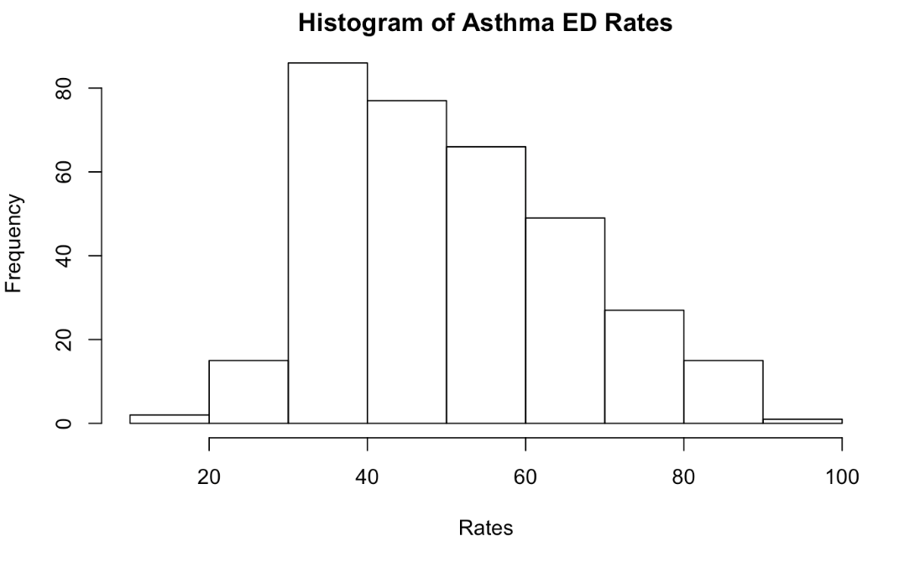

Figure 3

Figure 4 Chart, scatter chart

Description automatically generated

Figure 5 Chart, scatter chart

Description automatically generated